Lab-06
Name=Abdul Ahad Razaq
Roll no=2502047
Code= https://github.com/ahadabbasi5785/data_structure_lab

Question1=
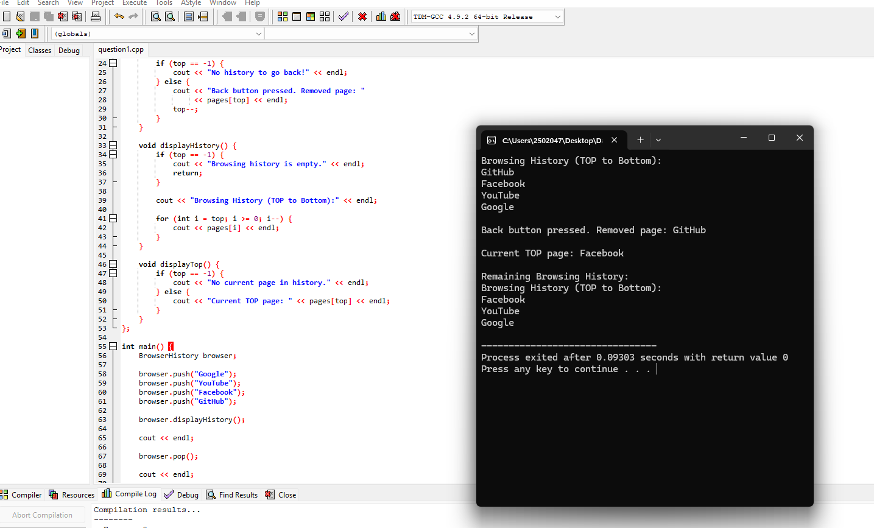
Question2=

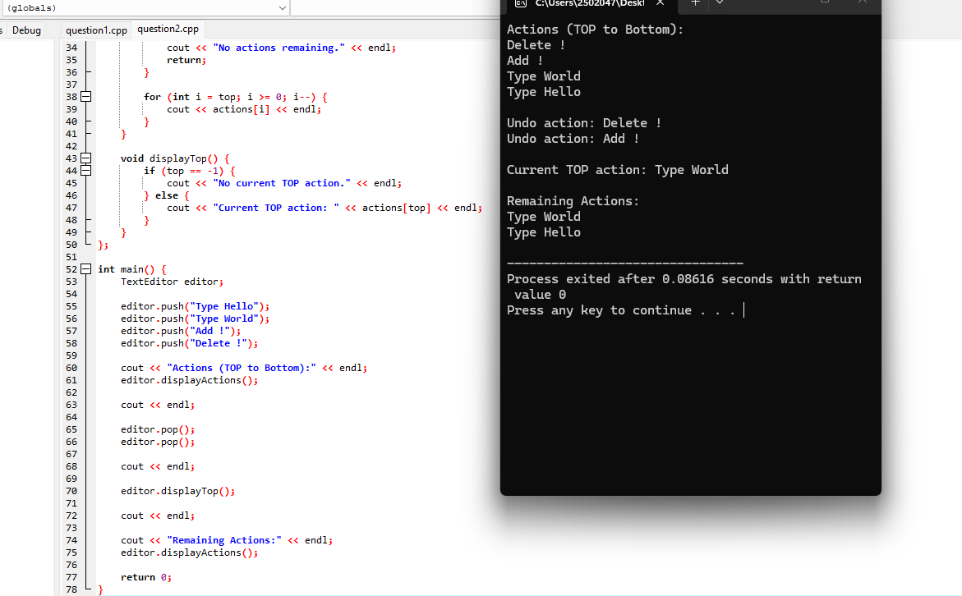
Question3=
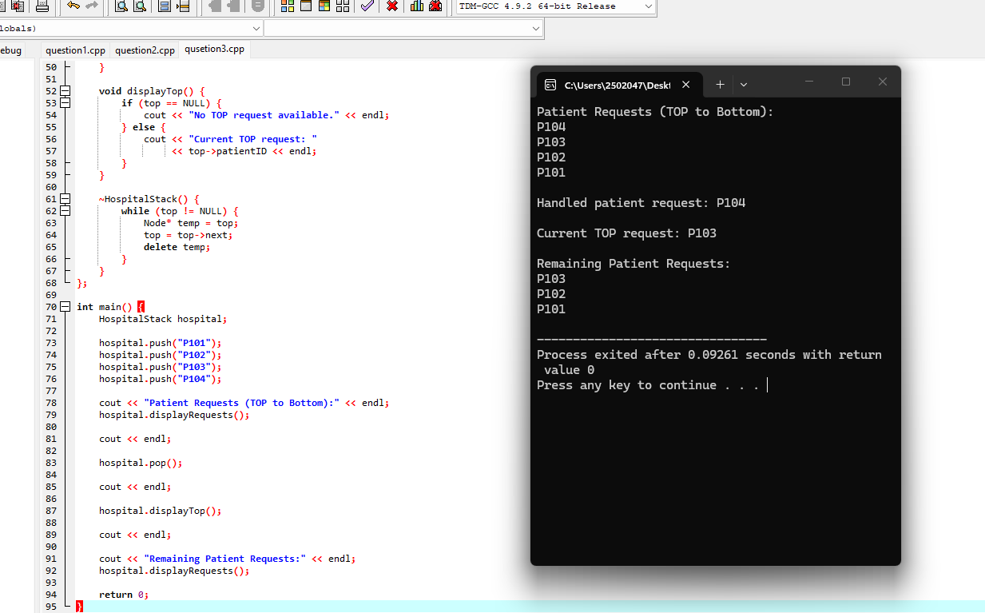
Question4=
